**AgriHat**

Project By

Vaishnavi Pankaj More

Aishwarya Narayan Dhangar

Vedika Eknath Patil

Sakshi Rajesh Karande

Under the Guidance of

Prof. Ganesh Palave

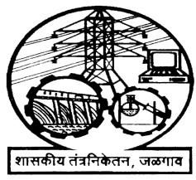

# Department Of Computer Engineering

Government Polytechnic, Jalgaon Semester – VI, Third Year

2022 - 2023

**Department of Computer Engineering**

**Government Polytechnic, Jalgaon**



# CERTIFICATE

This is to certify that

1. **Vaishnavi Pankaj More**
2. **Aishwarya Narayan Dhangar**
3. **Vedika Eknath Patil**
4. **Sakshi Rajesh Karande**

of CO6I (2022-23) have successfully completed Project on **“AgriHat”,** under the guidance of **“Mr. Ganesh Palave sir”** in partial fulfilment of the requirement for the award of diploma in computer engineering from Maharashtra State Board of Technical Education, Mumbai at Government Polytechnic, Jalgaon

**Prof. Ganesh Palave Prof.P.P.Chaudhari**

**Guide HOD**

**Department of Computer Engineering**

**Government Polytechnic, Jalgaon**



# CERTIFICATE

This is to certify that

1. **Vaishnavi Pankaj More**
2. **Aishwarya Narayan Dhangar**
3. **Vedika Eknath Patil**
4. **Sakshi Rajesh Karande**

of CO6I (2022-23) have successfully completed Project on **“AgriHat”,** under the guidance of **“Mr. Ganesh Palave sir”** in partial fulfilment of the requirement for the award of diploma in computer engineering from Maharashtra State Board of Technical Education, Mumbai at Government Polytechnic, Jalgaon

**Prof. Ganesh Palave EXTERNAL EXAMINER**

**GUIDE**

**Acknowledgment**

We have taken efforts in this project. However, it would not have been possible without the kind support and help of many individuals. We would like to extend our sincere thanks to all of them. We are highly indebted to our guide **Prof. Ganesh Palve Sir** for his guidance and constant supervision as well as for providing necessary information regarding the project and also for his support in completing the project. We express our thanks to our Principal **Mr. Parag Patil Sir** and our Head of the Department **Dr. P. P. Chaudhari** for extending their support. We would also thank our Institution and the faculty members without whom this project would have been a distant reality. Our thanks and appreciations also go to all people who have willingly helped us out with their abilities.

**Teacher Evaulation Sheet**

**Name of Students:** Vaishnavi More, Vedika Patil, Aishwarya Dhangar, Sakshi Karande

**Enrollment No.:**2000180536,2000180544,2000180545,2000180549

**Name of Project:** “**Agrihut**”

**Course Title:** Capstone Project- Execution & Report Writing.

**Code: 22060**

**Course outcome achieved:**

a) Write a problem task specification in existing system related to occupation.

b) Select collect and use require information knowledge to solve the problem.

c) Consider the ethical issue related to the project.

**\*Evaluation as per Suggested Rubric Assessment of Micro Project\***

|  |  |  |  |  |
| --- | --- | --- | --- | --- |
| **Characteristics to be accessed** | **Poor (Marks 1 -3 )** | **Average(Marks 4-5)** | **Good(Marks 6-8)** | **Excellent(Marks 8-10)** |
| Relevance to the course |  |  |  |  |
| Literative review/Information collection |  |  |  |  |
| Analysis o data and Representation |  |  |  |  |
| Completion of the target as per project Proposal |  |  |  |  |
| Report Preparation |  |  |  |  |
| Presentation of the Micro project |  |  |  |  |

**INDEX**

|  |  |  |
| --- | --- | --- |
| **SR NO** | **TOPIC** | **PAGE NO** |
| 1 | Abstract | 7 |
| 2 | Chapter 1 - Introduction | 8 |
| 3 | Chapter 2 – System analysis | 10 |
| 4 | Chapter 3 – Project Requirements | 12 |
| 5 | Chapter 4 – Project Design | 15 |
|  | 4.1 Feasibility Study | 15 |
|  | 4.1.1 Technical Feasibility | 16 |
|  | 4.1.2 Operational Feasibility | 17 |
|  | 4.1.3 Economical and Financial Feasibility | 18 |
|  | 4.2 Data Flow Diagram | 19 |
|  | 4.3 PERT | 22 |
| 6 | Chapter 5 – Software Development | 23 |
| 7 | Chapter 6 – Software Testing | 26 |
| 8 | Chapter 7 - Output | 29 |
| 9 | Chapter 8 - Conclusion | 43 |
| 10 | Chapter 9 - Future Scope | 44 |
| 11 | Chapter 10 - References | 45 |

**Abstract**

For several years, farmers in India have had little liberty in choosing markets and purchasers for their produce. All states in the country, except three, degree that marketing and selling of farm produce must be directed through state-owned mandis, retail markets where mediators (middlemen) crush farmers to increase margins. According to research, mediators have become dominating buyers of the agricultural market, resulting them to take control over the plight of the farmers and gulping all the profits. The farmers work day and night expecting a good yield. They use a lot of financial resources lending money and buying fertilizers, seeds etc. So, they have the right to enjoy every rupee gained on their corp. In this context, we propose a system which brings farmers close to the retailers cutting the middlemen. The middlemen usually take up to 70% of the profits of farmers leaving them helpless. Our system consists of a mobile or web application which will serve as a platform for farmer the growers and retailers or customers to sell and buy their farm products. This system aims at giving a profitable price to farmers to their farm products cutting the middlemen. This allows the retailers or the customers to buy products from the farmers at a lower than the normal price. This system is used to farmer and user. Farmer uploads their product with details and buyers view these details and book that product with in a time.

**Chapter 1- Introduction**

Agriculture is the backbone of India. More than 60% of Indian workers are involved in Agriculture. Agriculture refer to the cultivation of land to provide food. Agricultural products refer to crops, fruits, and vegetables. After agriculture second only to the service sector but over the past several years the number of agricultural workers in developed countries have decreased significantly. E-marketing is referred to those strategies and techniques which use online ways to reach target customers. E-Marketing is also known as Digital Marketing, or Online Marketing. E-marketing is the way to sell products over Internet. Farmers may use the Internet to sell products to customer and organizations. E-marketing is useful to the farmers as its serve customer all over the world 24*7. The cost incurring is also low.

Problems addressed from this project idea:

Farmers struggle for selling and convincing to middlemen for proper rates. The customer to shop virtually using internet and allow customers to buy products of their own choice and better rates.

The services of customer and Farmer eliminating the middlemen between them. Time wastage of farmers and customers for better rates and selling/buying. Insufficient agricultural support facilities. Lack of “Common Platforms” for the farmers in India.

Farming is the Prime Occupation in India in spite of this, today the people involved in farming belongs to the lower class and is in deep poverty. The Advanced techniques and the Automated machines which are leading the world to new heights, is been lagging when it is concerned to farming, either the lack of awareness of the advanced facilities or the unavailability leads to the poverty in farming. Even after all the hard work and the production done by the farmers, in today’s market the farmers are cheated by the Agents, leading to the poverty. Agro-marketing would make all the things automatic which make easier serving as a best solution to all the problems. Farmer’s e-Market will serve as a way for the farmers to sell their products across the country just with some basic knowledge about how to use the website. The site will guide the farmers in all the aspects. Getting availed to the required information related to the markets and different products can be made possible through the SMS facility. Farmers e-Market is the web application that will help the farmers to perform the agro-marketing leading to achieve success and increase in their standard of living. The Marketing facility would allow the farmers to have a view of the bills created and the related information in their accounts. An Authorized-agent would serve as away for the farmers to sell their products in the market. The Centralized market committee will have control on the Agents through business activities review. In rural are at he SMS facility would give the required market information where internet cannot be availed. Government will put forward the new schemes for the farmers. Compensation will be provided for the farmers in case of any loss to the production due to some natural calamities.

**Chapter 2- System Analysis**

* **Existing System:**
* Existing system does not provide proper guidance to formers how to sell their products through online.
* The current system does not provide classes to formers to get knowledge about how to operate computer.
* The current system does not providing courses to learn basics of how to register into sites, sell crops and transactions.
* The current system does not provide websites to formers in their local languages.
* **Proposed System**:
* The development of this new system contains the following activities, which try to automate the entire process and aware the formers to globalize their products.
* The system provides authorized logins to formers and wholesalers.
* It gives training to former who does not have knowledge of basics of computer.
* Provides facility of scheduling classes for farmers who enrolled for basic courses.
* Sites are also available in their local languages as per states.
* User friendliness is provided in the application with various controls provided by system rich user interface.
* Authentication is provided for this application only registered users can access transaction details.
* Online sales and purchase details of both formers and wholesales are should maintain in secured way.
* Report generation features is provided using to generate different kind of reports which are helpful to knowing information of sales and purchases.

**Chapter 3- Project Requirement**

This chapter will provide a full description of the system and its user requirements. Then it depicts the functional and non-functional requirements that have been collected.

**System description**

The system is created to help bring together all local vendors. We want to help make each stronger individually as a collective whole by providing simple lines of communication, logistics and support within the relationship of producers to buyers and producers to producers &essentially creating an online farmers market for that offers consistent connection between all producers and buyers. The main motive of the project is to sell local and buy local.

The central concept of the application is to allow the buyer to shop virtually using internet and allow customers to buy products of their own choice. Improve the services of buyers and producers eliminating the middlemen between them. Maintaining details of customer payments, product receipts, and also updating of the same. The information pertaining to the products are stored on RDBMS at the server side. Since, all the data are stored in the database analysis of data can be done. The admin can keep record of what product is sold to which buyer from which farmer. Every data can be accessed and analysis can be done which will help in generation of reports for future use.

**System Requirements**

Before creating system, it is necessary to visualize the layout, design and all features intended to be incorporated. In addition, how users will interact with each page and icon and how the website should perform (behavior, load time etc.). Requirements are the necessary attributes in the system, a statement that identifies a capability, characteristic or quality factor of the system in order to have value and utility to the users. Once the requirements are set, developers can initiate the other technical work including system design, development, testing, implementation, and operation. For creating this College Admission System we required a computer system with 8 GB RAM, i3 processor Specifications. For any system, there are functional and non-functional requirements to be considered while determining the requirements of the system. The functional requirements are user ―visible‖ features that are typically initiated by stakeholders of the system, such as generate report, login, and signup. On the other hand, non-functional requirements are requirements that describe how the system will do what it is supposed to do, for example, security, reliability and maintainability.

**Functional Requirements**

1. Admin

* Manage user
* Send notification
* To Check Details of user
* Admin can approve or reject form

1. User

* Registration
* Fill Form
* Check daily update

**Non-Functional Requirements**

1. Security Every user has his own account and only authorized users can access the system with username and password. The data should be encrypted while storing
2. Performance Easy tracking of records and updating can be done.
3. Availability The system is available to users anytime, anywhere, just need an Android device or desktop. An internet connection is required to sync data with the web module. Also, the application supports web module for analysis and management.
4. User Friendly The system has a friendly user interface and the system very interactive.

**Hardware Requirements**

➢ Desktop - Windows 7 and above devices

➢ RAM - 1GB and above for better experience

**Software Requirements**

➢ Visual Studio –used to as an editor to implement code of PHP, CSS, HTML, etc.

➢ Google Chrome or Any Browser – Use for executing code of our project.

➢ MySQL Database – Used for creating database for storing students’ information.

**Chapter 4- Project Design**

**Feasibility Study**

As we have compared the existing system vs propose system the next step to to perform analysis on feasibility study on the project Prior to stating whether the system we have to develop is feasible or not we believe that we should emphasize on what is implied by the word "Feasibility".

Feasibility study is one of stage among important four stages of Software Project Management Process. As name suggests feasibility study is the feasibility analysis or it is a measure of the software product in terms of how much beneficial product development will be for the organization in a practical point of view .Feasibility is the measure of how beneficial or practical the development of the system will be to the organization. It is a preliminary survey for the systems investigation.

* **Types of Feasibility**

These measures include-

* Technical Feasibility
* Operational Feasibility
* Economical Feasibility

**Technical Feasibility**

In simple words, a technical feasibility study gives a report on whether there exist required resources and new technologies which will be used for proposed software development. In developing our project ,We analysed and evaluated whether the project’s current resources, including hardware and software along with the technical requirements of the proposed system.

Evaluating the technical feasibility is the trickiest part of a feasibility study. This is because, at this point in time, not too many detailed designs of the system, making it difficult to access issues like performance, costs on of the kind of technology to be deployed) etc. A number of issues have to be considered while doing a technical analysis

Before commencing the project, we have to be very clear about what are the technologies that are to be required for the development of the new system We listed out what

Understand the different technologies involved in the proposed system:

* Find out whether the organization currently possesses the required technologies?
* Is the required technology available with the organization?
* If so, is the capacity sufficient?
* For instance – “Will the current printer be able to handle the new reports and forms required for the new system?
* type of language we are going to use for developing frontend
* type of language for backend?
* Whether our computers are capable of implementing the system?
* What will happen if Heavy tasks are not executing properly?
* What skill sets are required to us in development

**Operational Feasibility**

Proposed project is beneficial only if it can be turned into information systems that will meet the organizations operating requirements. Simply stated, this test of feasibility asks if the system will work when it is developed and installed. Are there major barriers to Implementation? Here are questions that will help test the operational feasibility of a project

Is there sufficient support for the project from management from users? If the current system is well liked and used to the extent that persons will not be able to see reasons for change, there may be resistance Are the current business methods acceptable to the user? If they are not, Users may welcome a change that will bring about a more operational and useful systems. Have the user been involved in the planning and development of the project? Since the proposed system was to help reduce the hardships encountered.

In the existing manual system, the new system was considered to be operational feasible.

1. Whether the system provides right information to the right place. In the current system, which is the semi computerized system the information may be lost in the Process of sending from one place to another. This is mainly due to human interaction in the process of transferring information from one place to another.
2. Determine whether the GUI is displayed correctly.
3. Determine whether the Database related queries are getting executed properly.

**Economical and Financial Feasibility:**

Economic feasibility in terms of software development helps companies to examine the development costs and financial gains.And to be economically feasible means the cost incurred in new software development must exceed its benefits Furthermore, the total cost of the software project, including any unplanned expenses, must be known beforehand.

In making recommendations a study of the economics of the proposed system should be made. The proposed system must be justifiable in terms of cost and benefit, to ensure that the investment in a new/changed system provide a reasonable return. According to the computerized system we propose, the costs can be broken down to two categories.

Economic feasibility attempts 2 weight the costs of developing and implementing a new system,against the benefits that would accrue from having the new system in place. This feasibility studies gives the top management the economic justification for the new system. A simple economic analysis which gives the actual comparison of costs and benefits are much more meaningful in this case. In addition, this proves to be a useful point of reference to compare actual costs as the project progresses. There could be various types ofintangible benefits on account of automation

These could include increased customer satisfaction, improvement in product quality better decision-making timeliness of information, expediting activities, improved accuracy of operations, better documentation and record keeping, faster retrieval of information, better employee morale

1. Costs associated with the development of the system.
2. Costs associated with operating the system.
3. Costs associated with Maintenance of the project.

**Data Flow Diagram**

LEVEL 1 DFD FOR ADMIN

Login

Login

Login

LEVEL 1 DFD FOR Seller

Info

Information

Details

Message

Offers

Farmer

LEVEL 1 DFD FOR Buyer

Info

Information

Details

Message

Offers

Farmer

**PERT**

Pert chart is organized for events ,activities or tasks. It is a scheduling device that shows graphically the order of the tasks to be performed. It Enables the calculation of the critical path .The time and cost associated along a path is calculated and the path requires the greatest amount of elapsed time in critical path

Design Database

Code Database

Integrate and test

Specification

Design a GUI Part

Code a GUI Part

Write User Manual

Implementation

**Chapter 5-Software Development**

**Communication**

Software development process starts with the communication between customer and developer. According to need of project, gathering of the requirements related to project are done.

**Planning**

It includes complete estimation and scheduling (complete timeline chart) for project development and tracking.

**Modeling**

It includes detailed requirement analysis and project design. It includes coding and testing steps. Design details are implemented using html,css,javascript programming language.

**Advantages Of Current System**

* We can buy a products like Herbicides, Pesticides, Farmers Equipments etc.
* Intrested Farmer and seller Sell their Product on this platform.
* Farmers can buy Products on Offer and on EMI.

**Technologies Used In Agrihat**

**1.HTML**

HTML or Hypertext Mark-up Language is a standard mark-up language for web application development. Web browsers read HTML files and convert them to graphical itemson viewport. HTML allows images and objects to be embedded and can be used to create interactive forms. It provides a means to create structured documents by denoting structural semantics for text such as headings, paragraphs, lists, links, quotes and other items

**2.JavaScript**

JavaScript provides the behavioural of the web elements included in HTML. It also provides data binding for the HTML elements. Also, JavaScript provides a way to connectwith database and fetch the data real-time.

1. **CSS**

CSS or Cascade Style Sheet is a way to create a look to HTML elements. This makes the page more interactive as compared to plain HTML elements. Along with this bootstrap framework also provide an effective way for designing

**4.PHP**

PHP can actually do anything related to server-side scripting or more popularly known as the backend of a website. For example, PHP can receive data from forms, generate dynamic page content, can work with databases, create sessions, send and receive cookies, send emails etc. There are also many hash functions available in PHP to encrypt user’s data that makes PHP secure and reliable to be used as a server-side scripting language. So these are some of the abilities of PHP that makes it suitable to be used as server-side scripting language.

* **RDBMS**

A Relational database Management System (RDMS) is the database management system that is the based on Relational model as invented by E.F. Codd of the IBMs San Jose. Research Laboratory. Many popular database currently in use are based on the Relational database model

RDBMS have become a predominant choice for the storages of information in new database used for financial records, manufacturing and logistical information, personal data, and much more since the 1980s .Relational database have often replaced legacy hierarchical database and network databases because they are easier to understand to use. However, relational databases have been challenged by object database. Which are introduced in an attempt to address the object -relational impedance mismatch in relational databases, XML database.

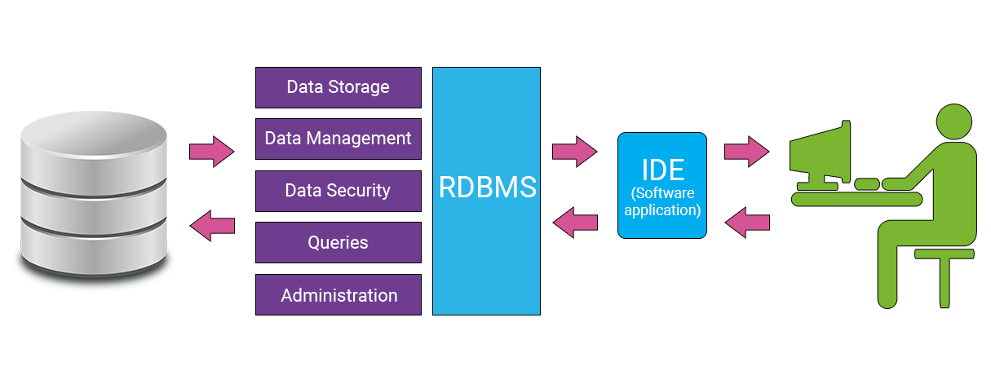

**Chapter 6-Software Testing**

Testing is the process of evaluating a system or its component(s) with the intent to find whether it satisfies the specified requirements or not.

Testing is executing a system in order to identify any gaps, errors, or missing requirements in contrary to the actual requirements.

Each test is typically described by

• An initial system state.

• A set of actions to be performed.

• The expected results of the test.

Test cases are planned in accordance to the test process and documented with detailed test descriptions. These test cases use cases based on projected operational mission scenarios. The testing process also includes stress / load testing for stability purpose (i.e., at95%CPU use, system stability s still guaranteed. The test process thoroughly tests the interfaces and modules Software testing includes a traceable white box testing, black box testing and other test processes verifying implemented software against design documentation and requirements specified.

**TESTING REQUIREMENTS**

Testing can be done based on test cases. Test case has components that describes an input, action or event and an expected response, to determine if a feature of an application is working correctly For this project the application must generate the following,

•Valid user name

•Valid password he input given by the user must be checked from the database. Login ID={Valid login ID, Invalid login ID}Password= {Valid password, Invalid password, Empty}Steps formatting to carry out the test for Login Page-

•Valid Login page

•Enter Email ID

•Enter password

•Click Login

**UNIT TESTING**

As this system was partially GUI based WINDOWS application, the following were tested int his phase

1.Tab Order

2.Reverse Tab Order

3.Field length

4.Front end validations

In our system, Unit testing has been successfully handled. The test data was given to each and every module in all respects and got the desired output. Each module has been tested found working properly.

**INTEGRATION TESTING**

Test data should be prepared carefully since the data only determines the efficiency and accuracy of the system. Artificial data are prepared solely for testing. Every program validates the input data.

**VALIDATION TESTING**

In this, all the Code Modules were tested individually one after the other. The following were tested in all the modules

1.Loop testing

2.Boundary Value analysis

3.Equivalence Partitioning .

Testing In our case all the modules were combined and given the test data. The combined module works successfully without any side effect on other programs. Everything was found fine working.

**OUTPUT TESTING**

This is the final step in testing. In this the entire system was tested as a whole with all forms, code, modules and class modules. This form of testing is popularly known as Black Box testing or system testing .Black Box testing methods focus on the functional requirement of the software. That is, BlackBox testing enables the software engineer to derive sets of input conditions that will fully exercise all functional requirements for a program. Black Box testing attempts to find errors in the following categories; incorrect or missing functions, interface errors, errors in data structures or external database access, performance

**Chapter 7- Output**

**User Interface**

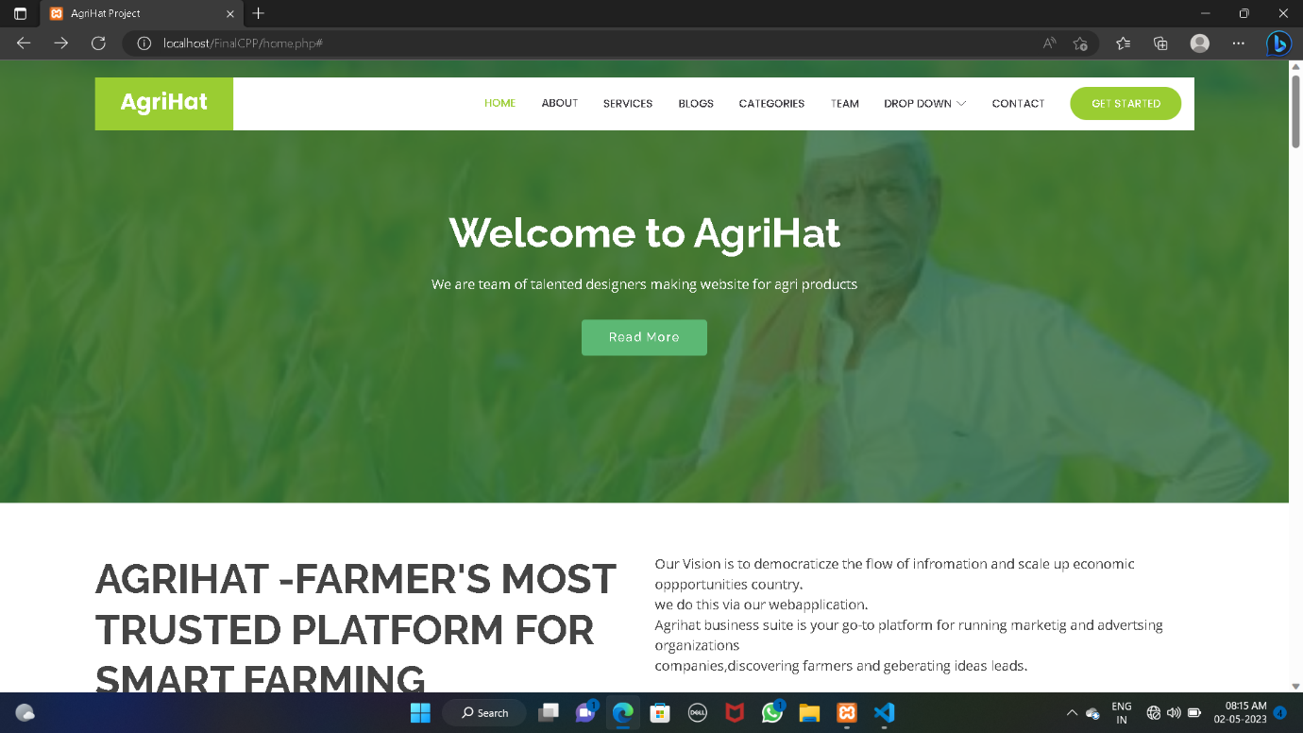**Home Page**

**About Us**

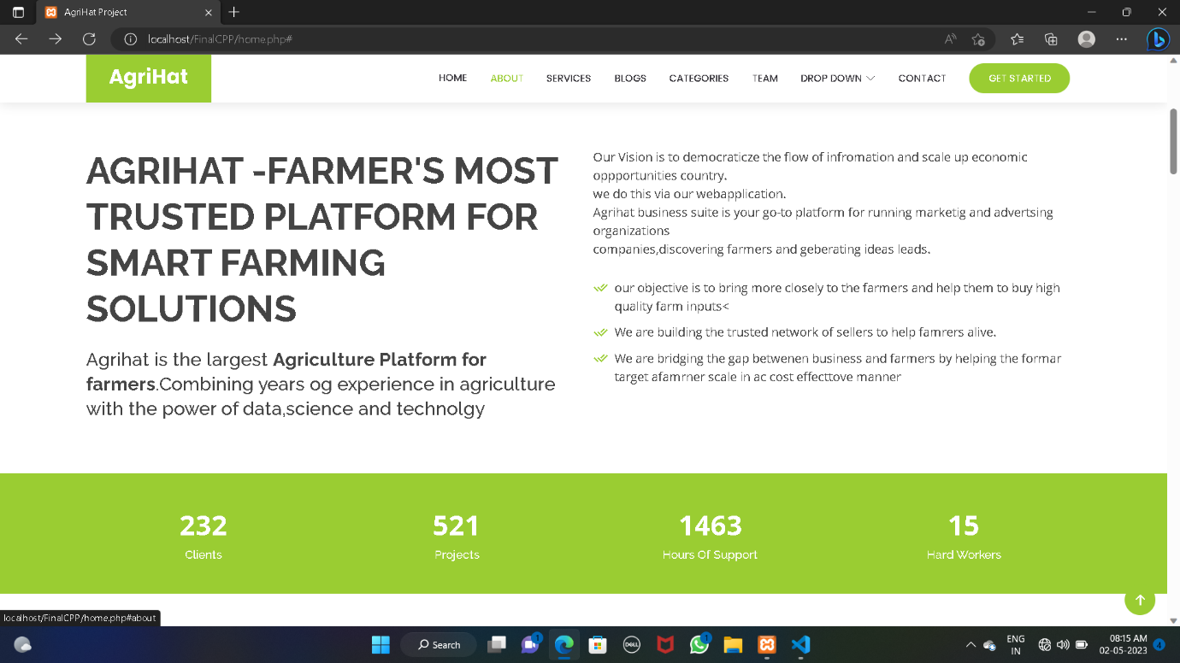

**Services**

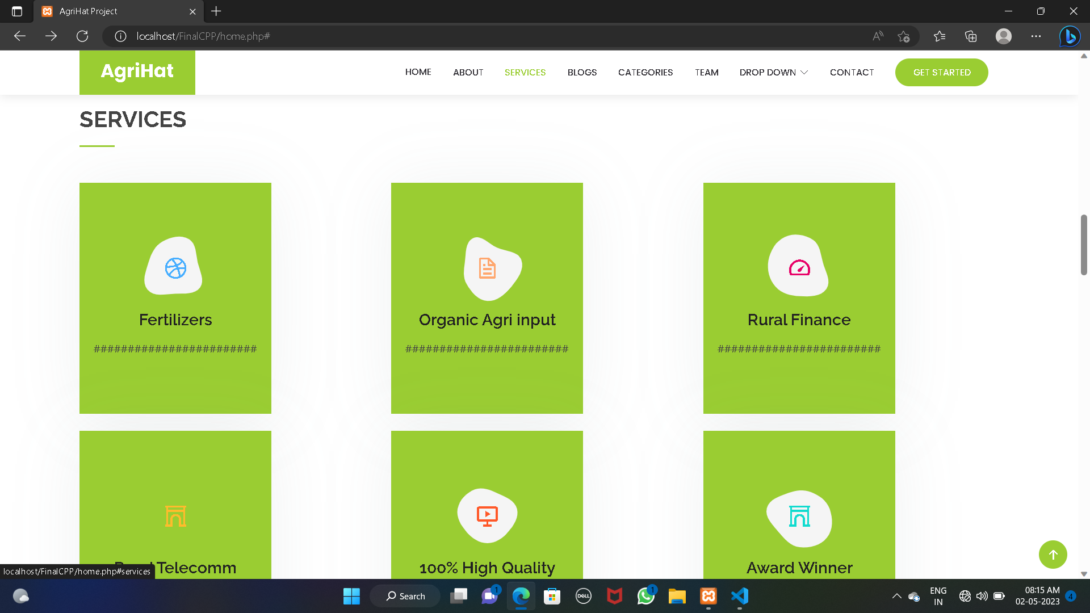

**Blogs**

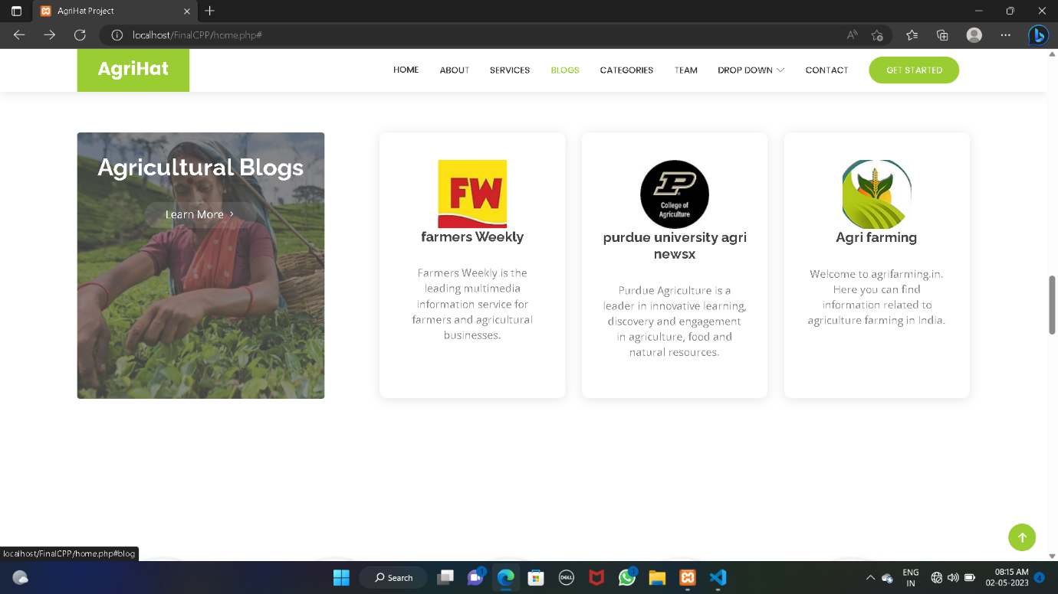

**Categories**

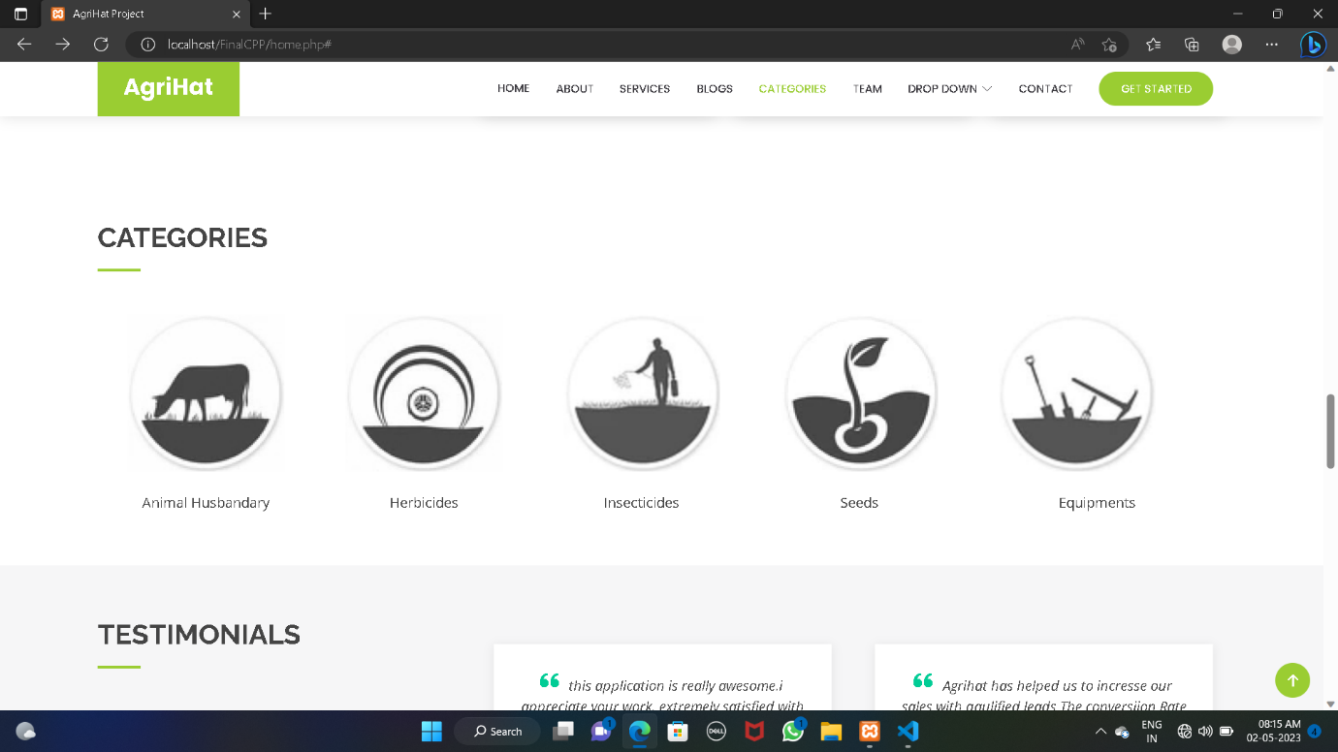

**Testimonials**

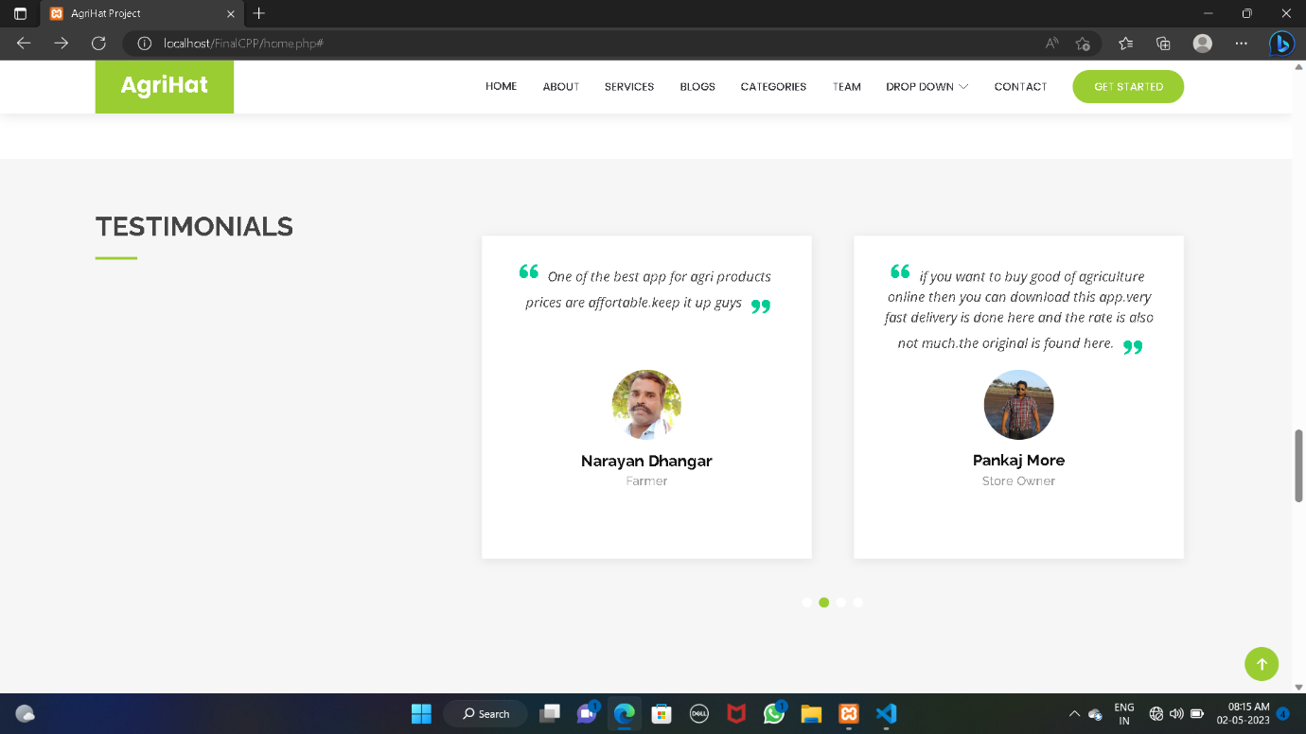

**Our Team**

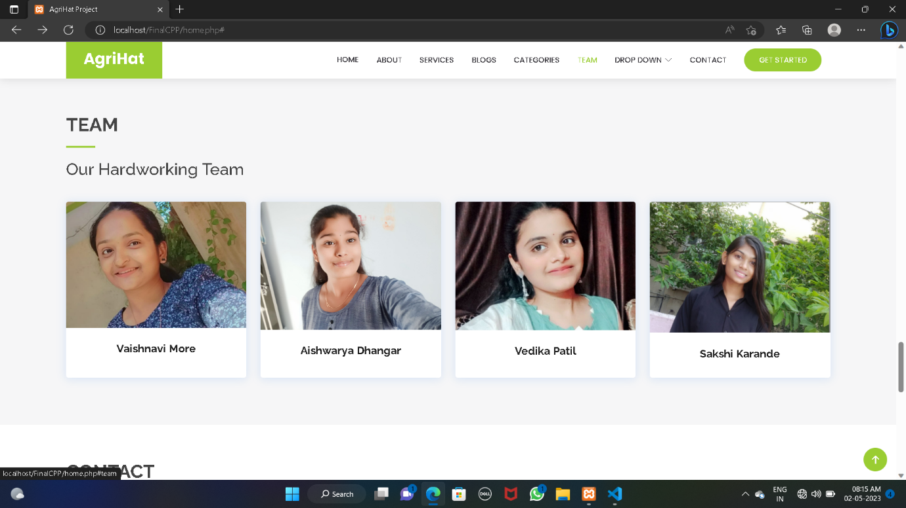

**Contact form**

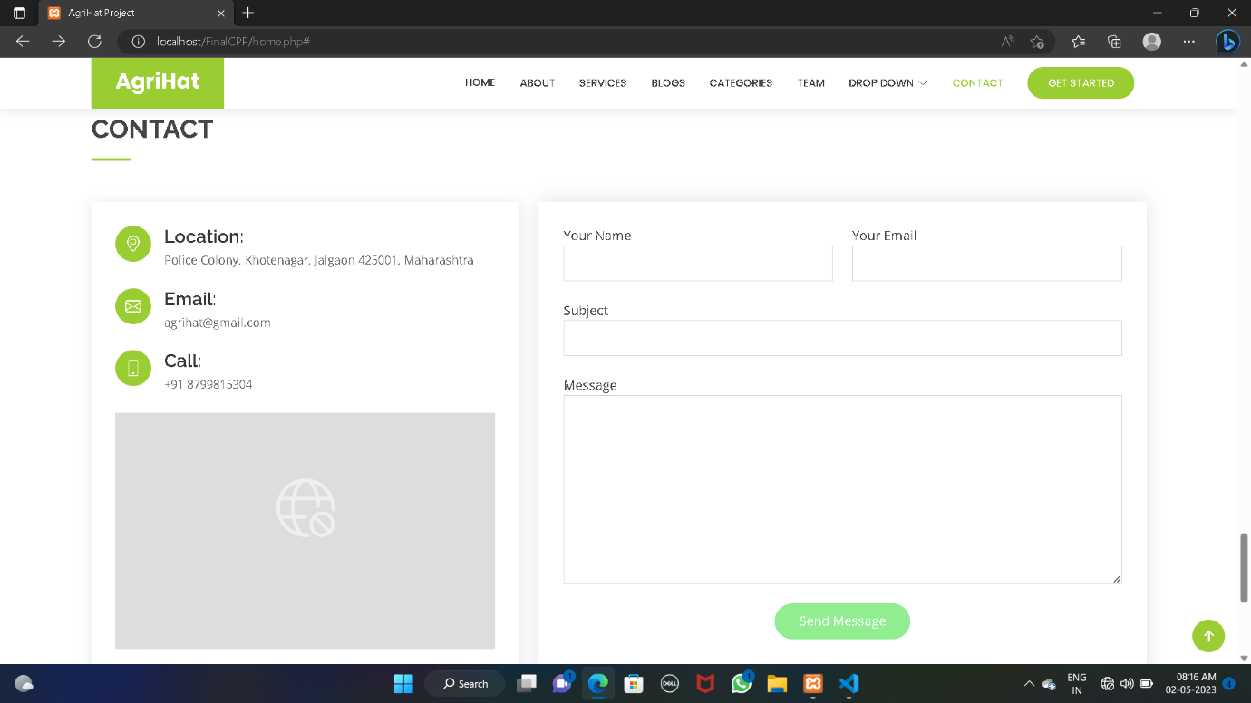

**Admin Panel**

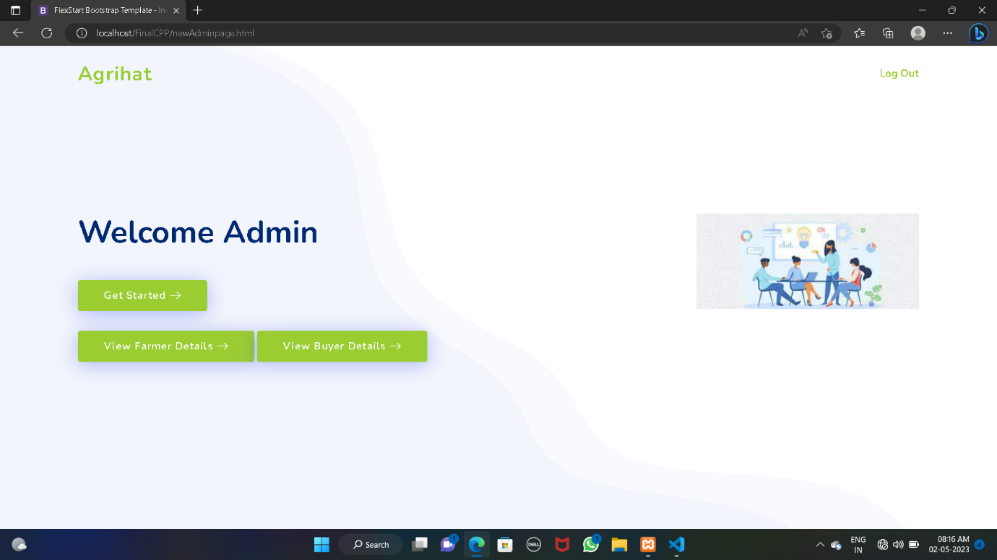

**Seller Section**

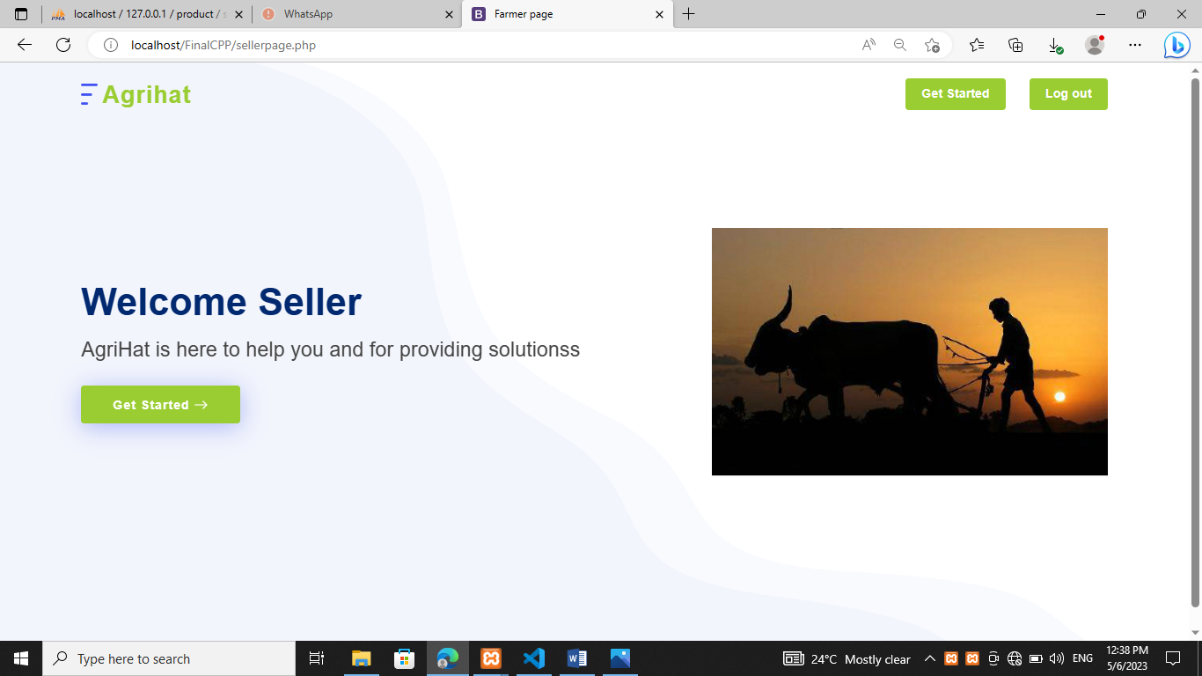

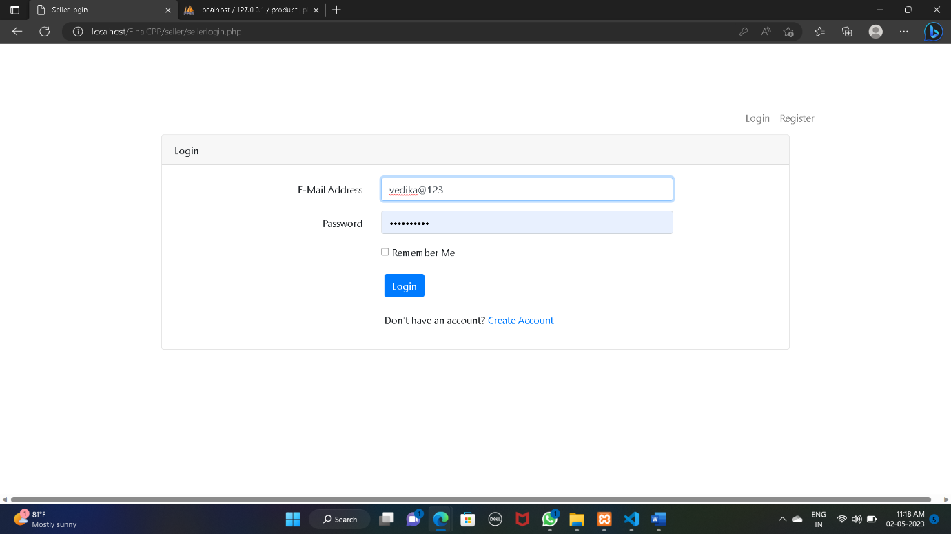

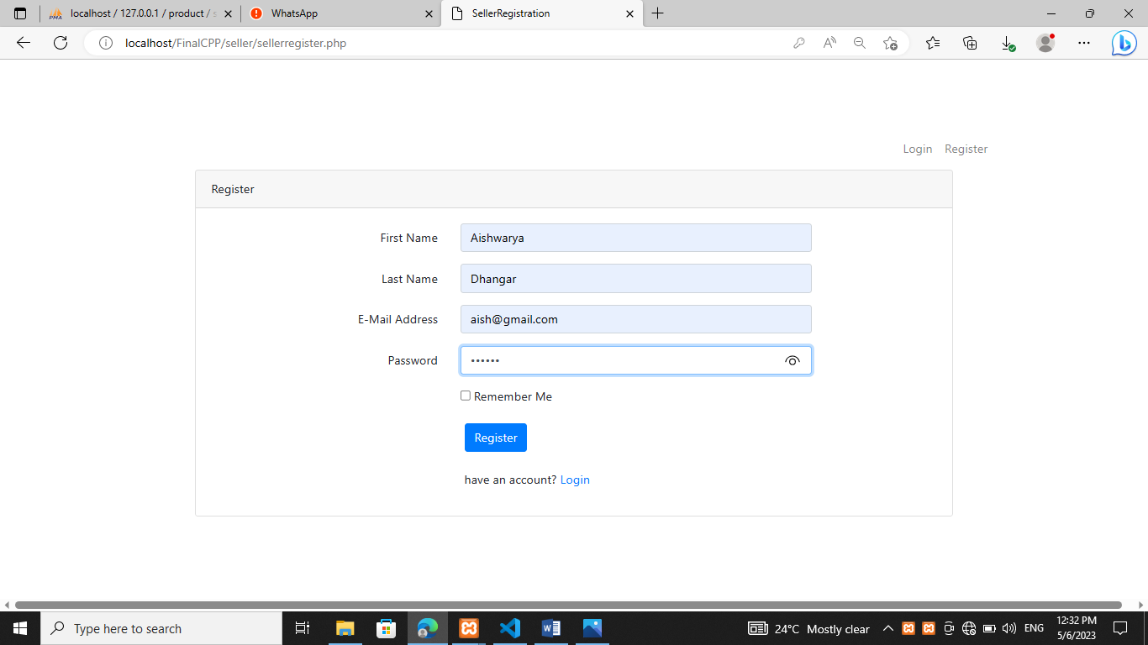

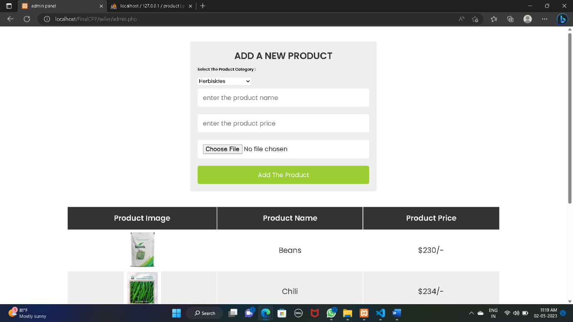

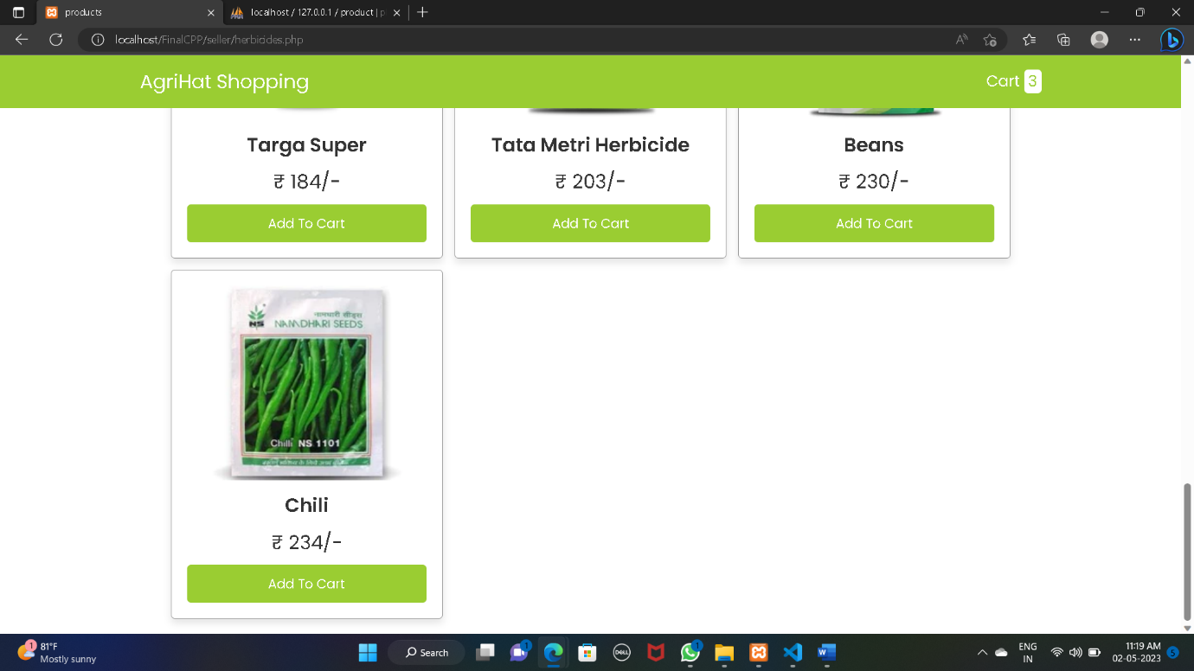

**Buyer Section**

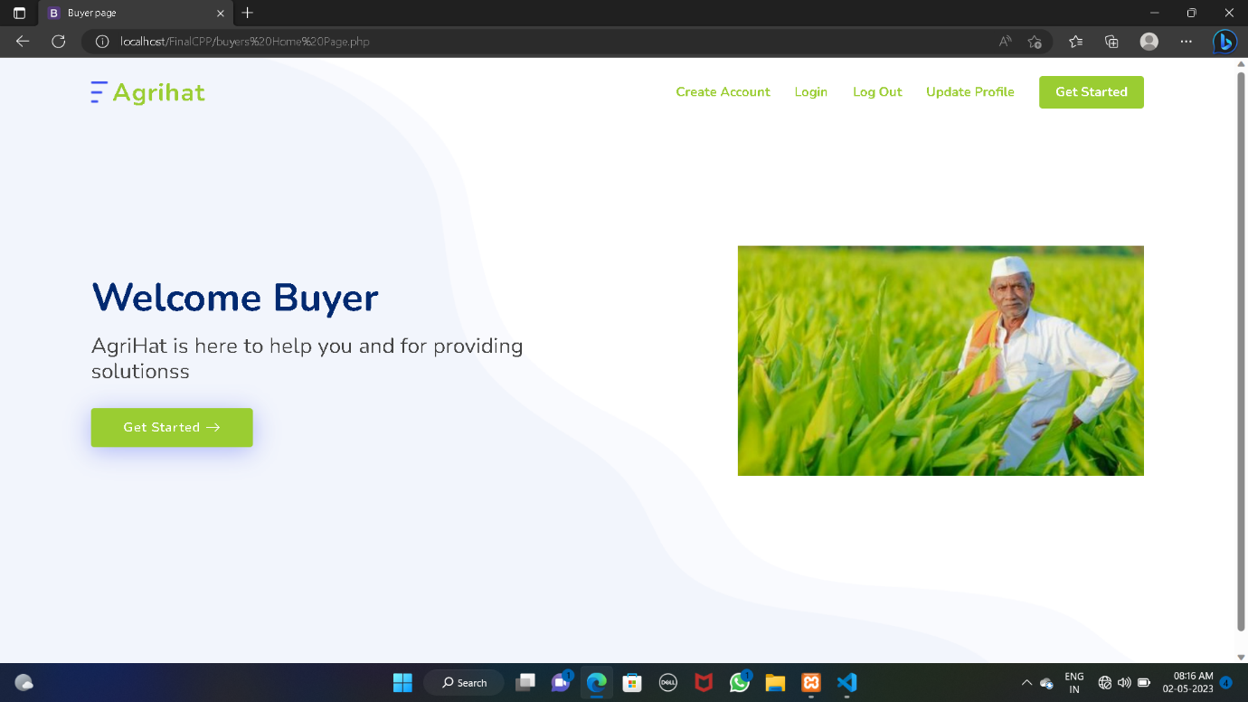

**Blogs for Information**

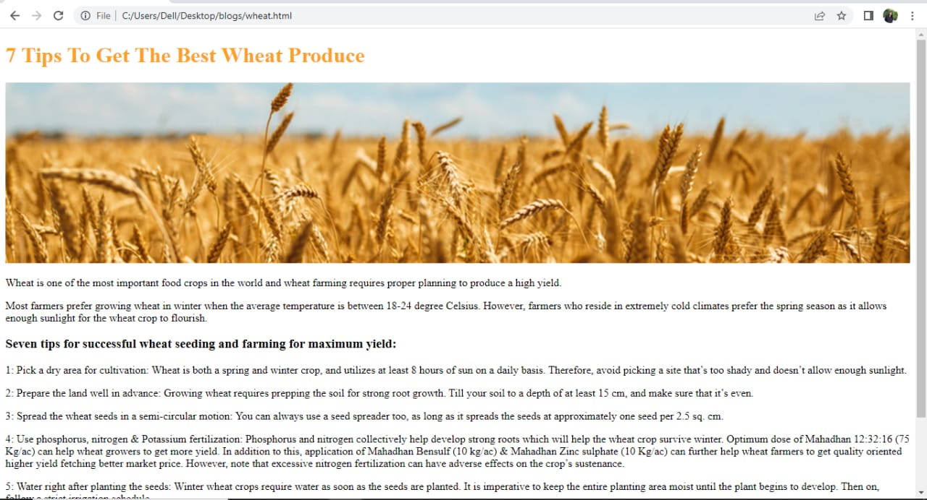

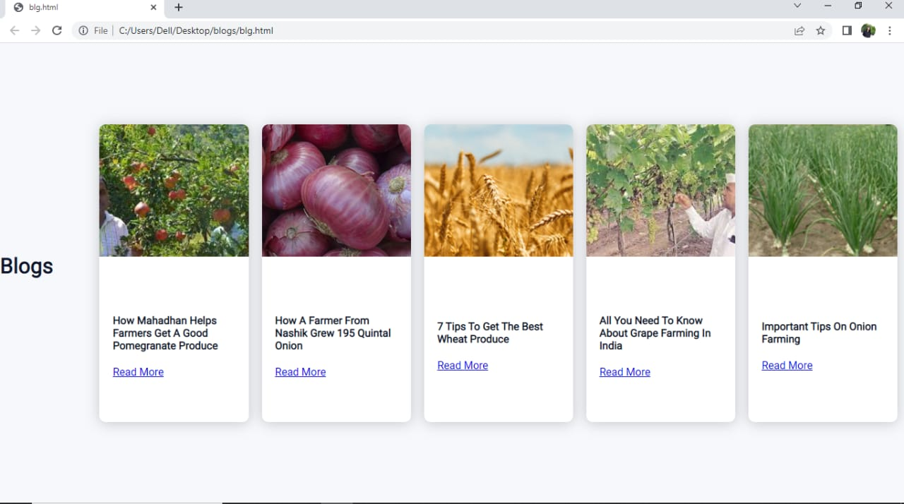

**Database**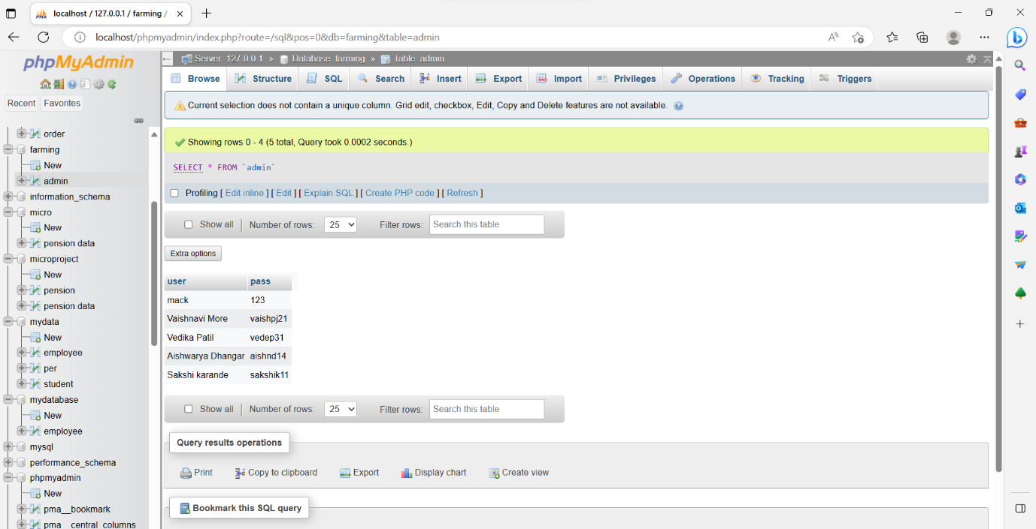

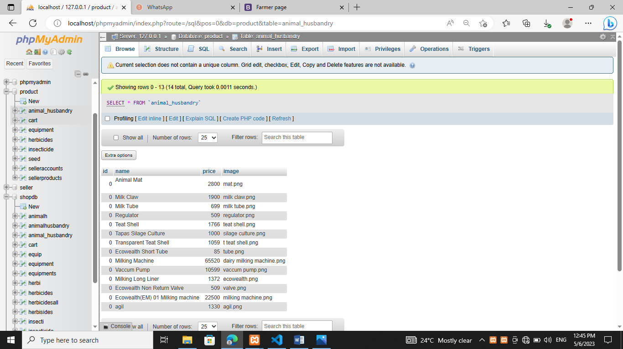

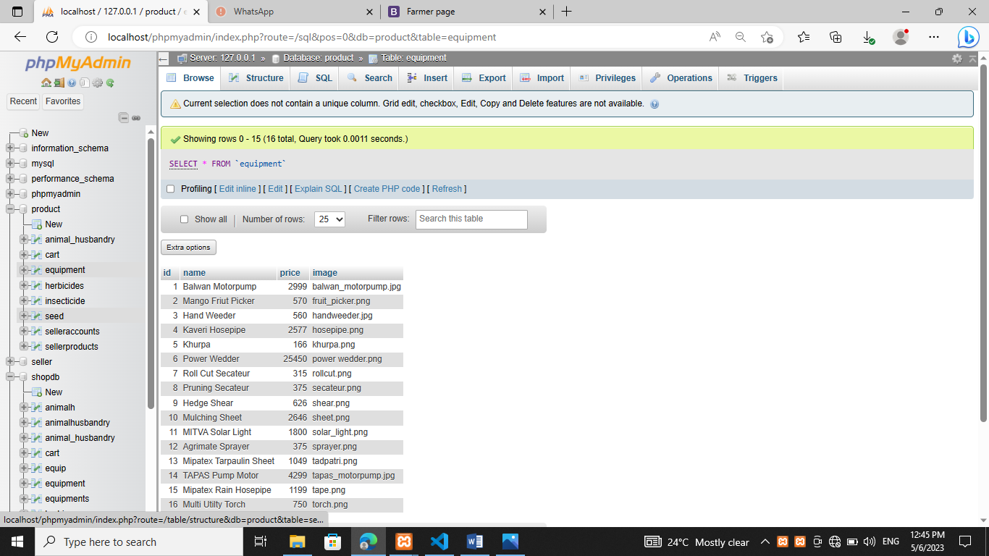

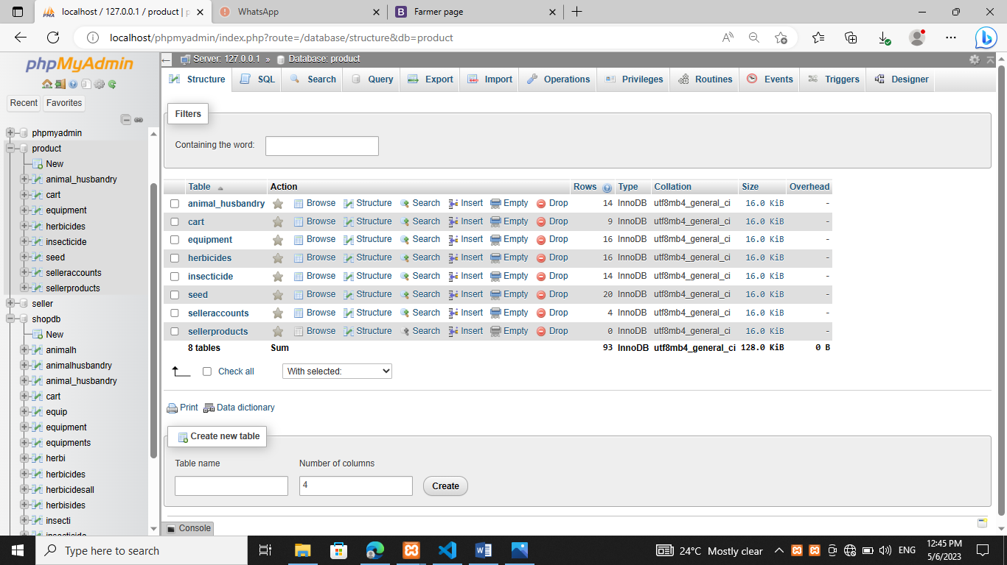

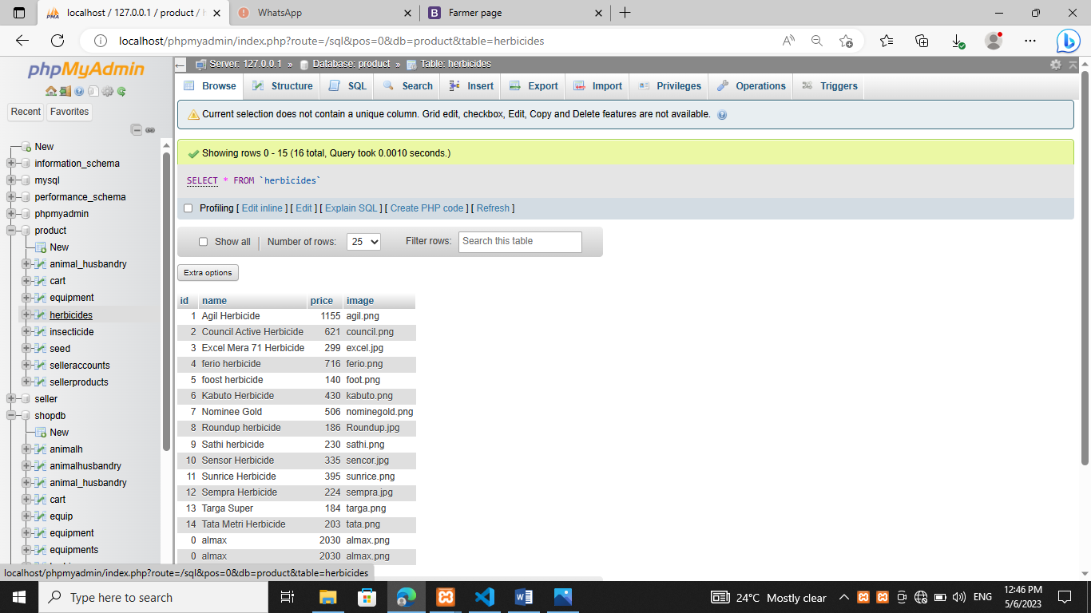

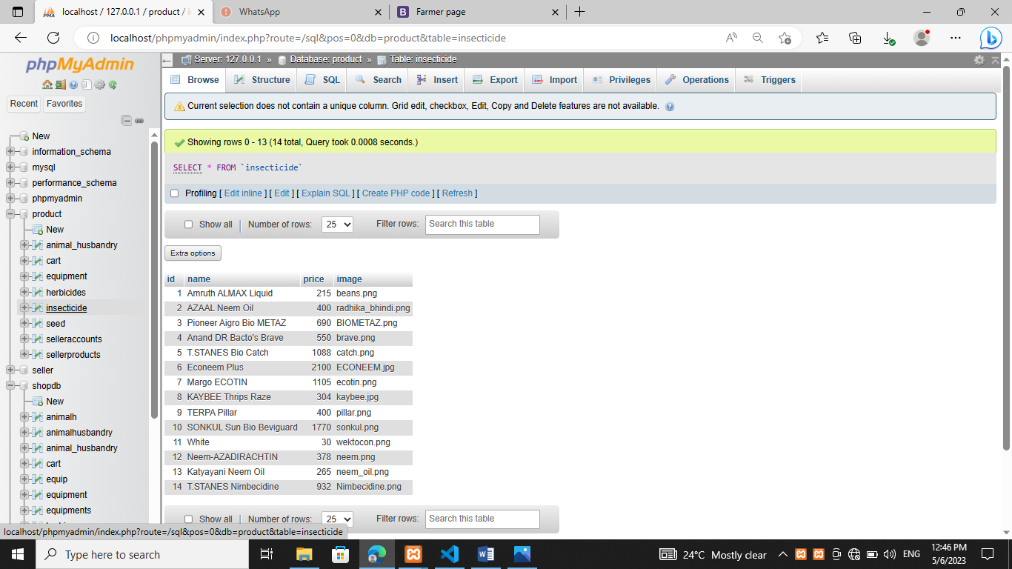

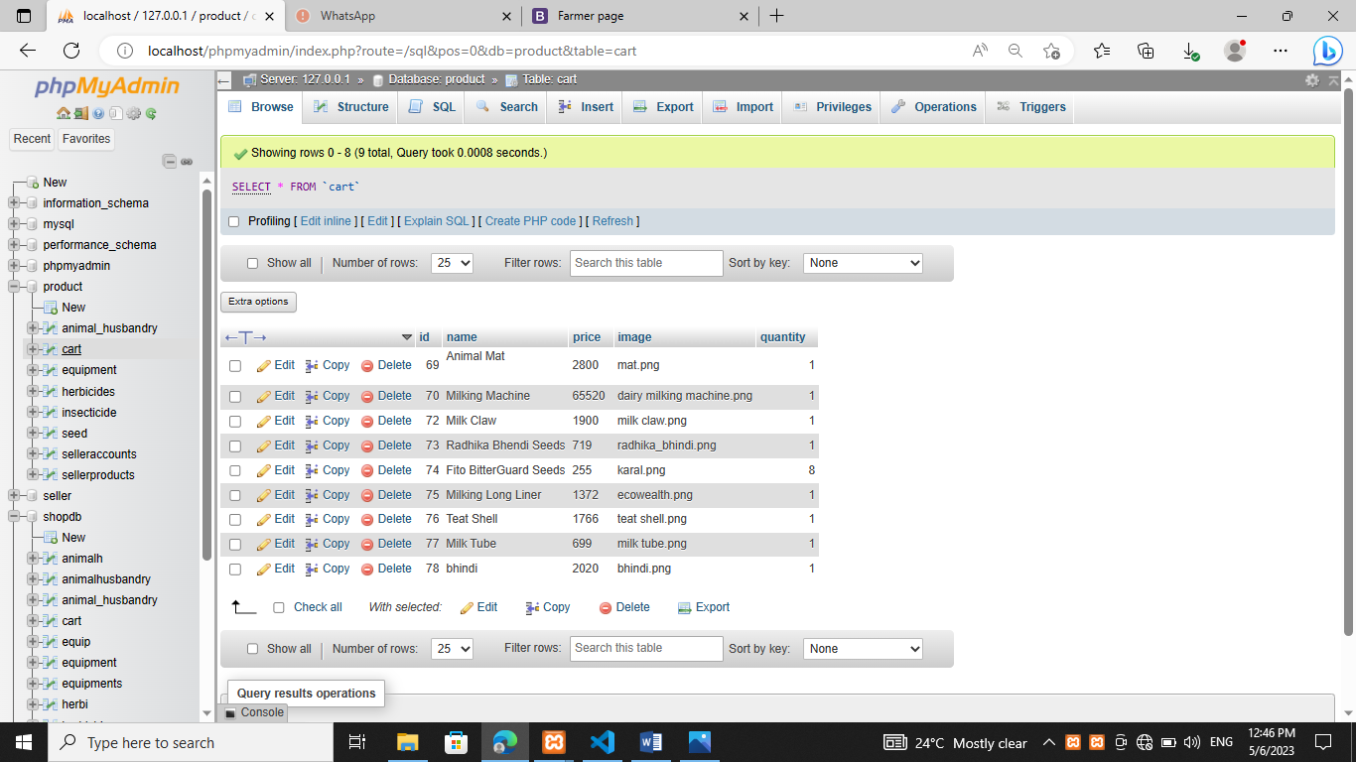

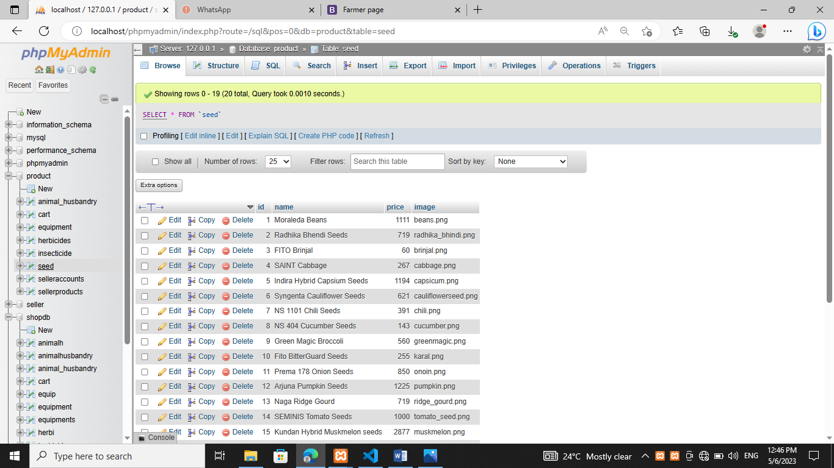

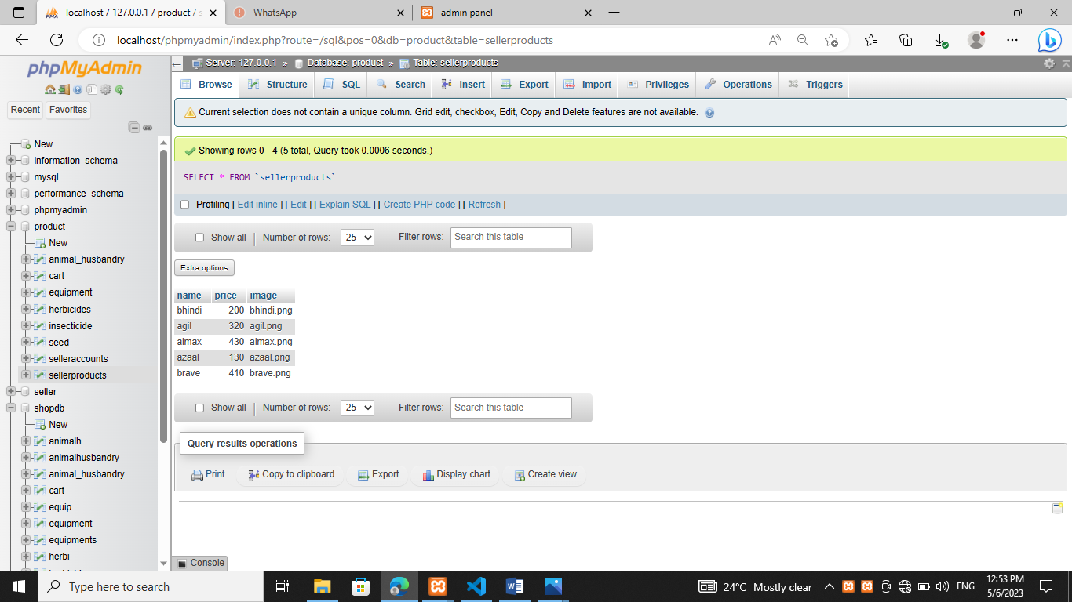

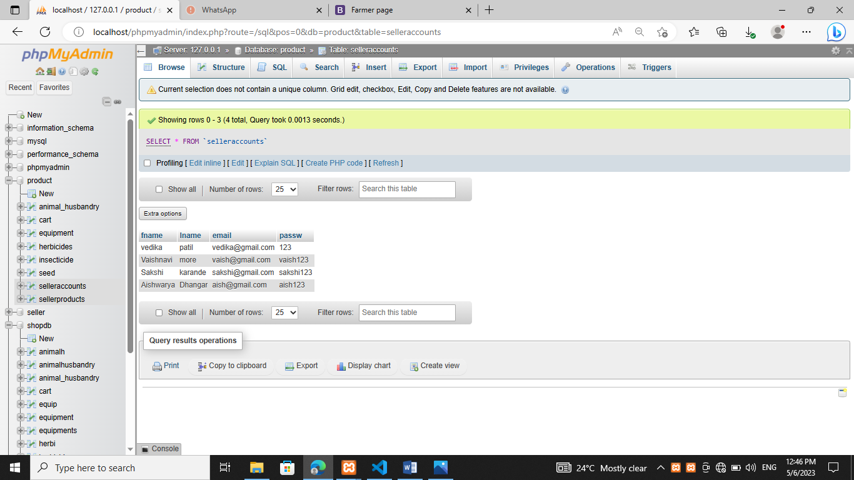

**Chapter 8-Conclusion**

This report helped us to plan the project to be implemented. We have gone through the problem and prepare the problem statement. We have designed the detailed SRS for the project and prepared outlook of the project.

The part of our system has been developed with much care that it is free of errors and at the same time it is efficient and less time consuming. The important thing is the system is robust. we have tried our level best to make site Dynamic as possible.

We have tried our level best to make the site as dynamic as possible .Also provision is provided for future developments in the system. The entire system is secured. This online system is made keeping in mind all pros and cons .The internet has become major source in modern business, thus electronic shopping has gained significance not only from the entrepreneur’s but also from the customer’s point of view. For the entrepreneur, electronic shopping generate new business opportunities and for the customer, It makes comparative shopping possible. As per the survey, most consumers of online stores are impulsive and usually make a decision to stay on a site within the first few seconds. We have designed the project to provide the user with easy navigation, retrieval of data and necessary feedback as much possible.

This project helps in understanding the creation of an interactive web page and the technologies used to implement it. The building of the project has given us the idea and a precise knowledge about how the application can be developed , how it connects to the database and how the data and web pages are modified as required.

**Chapter 9-Future Scope**

We can add printer in a future

We can give more advance software for the projects

We will host the platform on online servers to make it accessible worldwide

Integrate multiple load balancers to distribute load of the system

Create master and slave database to reduce the overload of the database queries.

Implement the backup for taking backup of codebase and database on regular basis on the different servers

Partial Payment:

Partial payment will be help user as well as farmer to buy and sell the product required by user accordingly.If the Product is more with farmer can update his leftover products for further purchasing.

Data Analysis:

With all the information stored in database. Admin can generate reports .The report will include deal the information about the transaction and also what all products are sold by which farmers.he analysis will be very useful for further use.

* Mandatory Charges:
* Application of charges at the time of registration will be implemented considering the need of the user as well as farmer

We have left the all the options so that the if there is any other future requirement in the system by the user for the enhancement of the system then it is possible to implement them .in the last We would like to thanks all the persons involved in the development of the system directly or indirectly

**Chapter 10-References**

* <https://www.scribd.com/document/88128965/e-farming>
* <https://www.researchgate.net/publication/274480387_E-Farming_using_Cloud_Computing>
* <https://codeshoppy.com/shop/product/agri-shop-for-farmers/>
* <https://www.scribd.com/doc/211343772/e-farming-dfd>
* <https://www.academia.edu/35197929/>